  L1 Spr25

Q1:

Software Requirements Specification

for

FUEXAMONLINE

Version 1.0 approved

Prepared by

Mac Viet Thong – SE181966

Ho Chi Minh (Xavalo) Campus

10/04/2025

Q2:

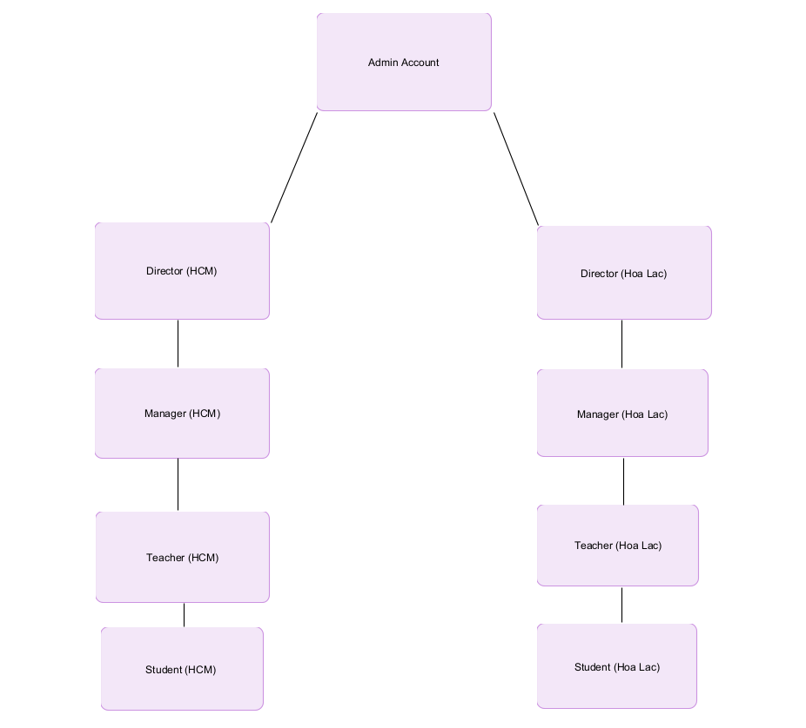

From this structure, the type of user with the largest number is likely the "Students." This is because each campus serves a large student body, and they represent the primary users of the FUEXAMONLINE website.

Q3:

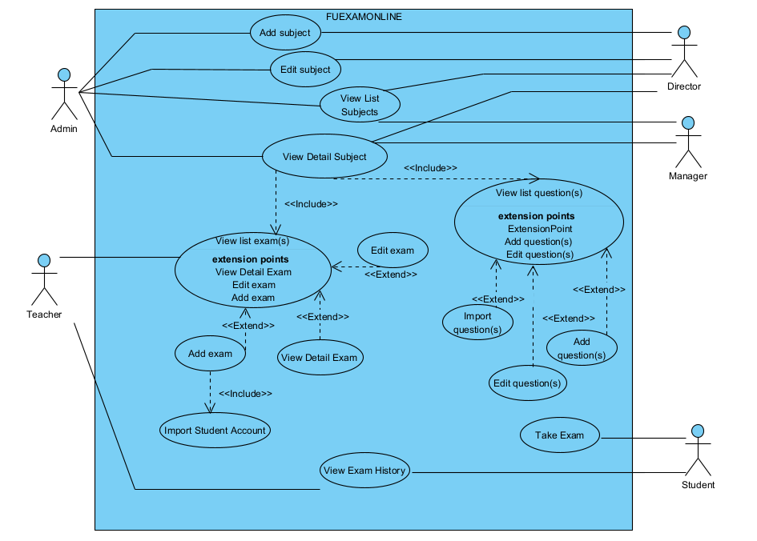

Q4:

|  |  |  |  |
| --- | --- | --- | --- |
| UC ID and Name: | UC - 1 Add Question | | |
| Created By: | THONGMVSE181966 | Date Created: | 10/04/2025 |
| Primary Actor: | Admin, Director | Secondary Actors: | Manager |
| Trigger: | * The Admin or Director initiates the process to add a new question while viewing list questions in detailed subject. * The system validates input data and saves the new question to the database. | | |
| Description: | This use case describes the process for adding a new question to the FUExamOnline system. | | |
| Preconditions: | 1. The user must be logged into the system with an Admin or Director account. 2. The user must have permission to manage question for each subject. | | |
| Post conditions: | 1. The question is successfully added and stored in the system. 2. The question becomes visible to authorized users, including staff, teacher and student. 3. A confirmation message is displayed to the user. | | |
| Normal Flow: | 1. The Admin/Director logs into FUEXAMONLINE. 2. The user navigates to the "View List Subject" section. 3. The user selects a subject to view details , then navigates to the “View List Question” section. 4. The user selects an option to add new question. 5. The system displays a form requiring details (expect Subject and Question number which is automatically generated by system) such as:  * Subject * Question number * Title * Content  1. The user fills in the required details and submits the form. 2. The system validates the input for unallowed words. 3. If validation passes, the system saves the new question to the database.   A success message is displayed, and relevant staff are notified. | | |
| Alternative Flows: | 1. If the user enters incomplete or invalid data, the system displays an error message, highlight the unallowed word(s) and requests corrections.   If the user cancels the process before submission, no changes are made to the system. | | |
| Exceptions: | 1. If the system encounters a database error, the question is not saved, and an error message is displayed. 2. If the user session expires, they are redirected to the login page. 3. If the internet connection is lost during submission, the system prompts the user to retry. 4. If unauthorized users attempt to access this function, the system denies access and logs the attempt. | | |
| Priority: | High | | |
| Frequency of Use: | High | | |
| Business Rules: | (0.2 point) All things in software are related to data. The business rules should be specific so that they can be designed and coded | | |
| Other Information: | (0.1 point) It may be a description of quality here for more info. | | |
| Assumptions: | (0.1 point) The assumptions on the data are related to this use case. | | |

**Q5:**

a. Security Requirements

- Only users with an @fpt.edu.vn email can log in to the system, and all authentication processes must be handled through OAuth 2.0 to ensure security.